Vrixzandro Cunamay Eliponga System Administration and Maintenance

BT1203 07 Laboratory Exercise 1

**For “Hello” file**

* **Content:** Open terminal application then type “vi Hello” to create and open a file in the vim editor application.

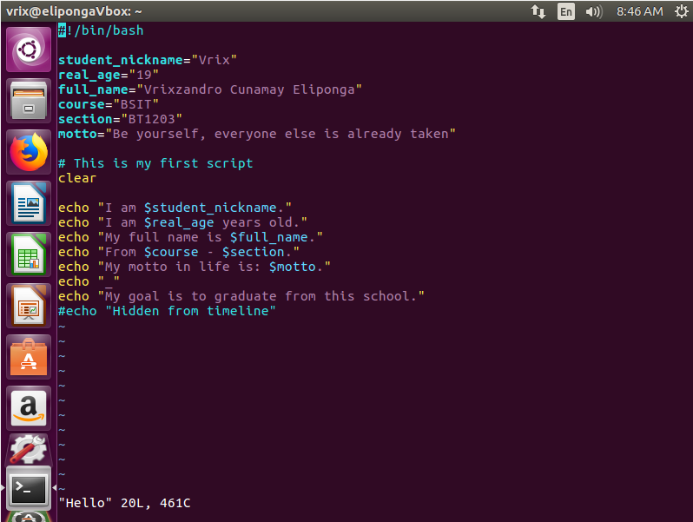

* **Saving file and setting executable pemission:** Press the **esc** button then type “:wq” to write the file and to quit the vim editor application. After that type “chmod 755 Hello” to set the user’s current permission to be able to **READ**, **WRITE** and **EXECUTE** the Hello file, type “ls -l Hello” to show the Hello file’s permissions.

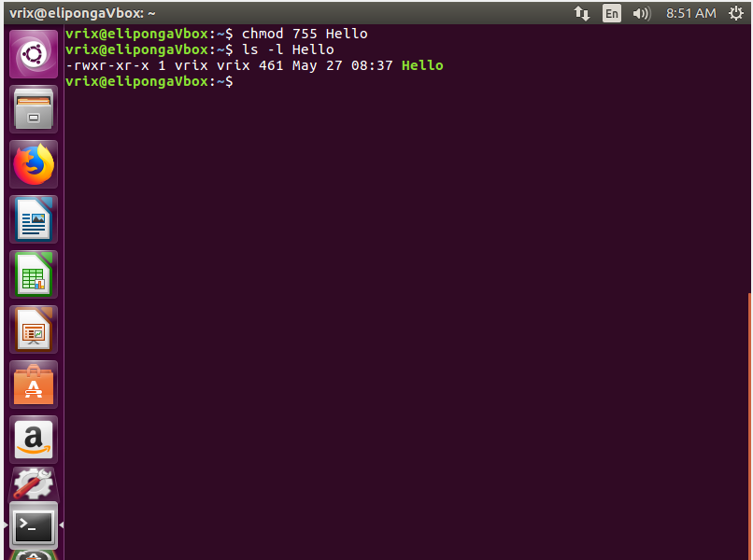

* **Executing the file**: Type in “**bash Hello**”, “**sh Hello**”, or “**./Hello**” in the terminal application to execute and run the Hello file.

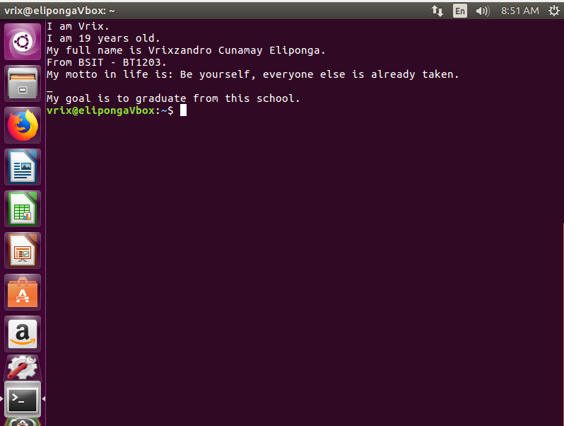

**For “Inform” file**

* **Content:** Open terminal application then type “vi Inform” to create and open a file in the vim editor application.

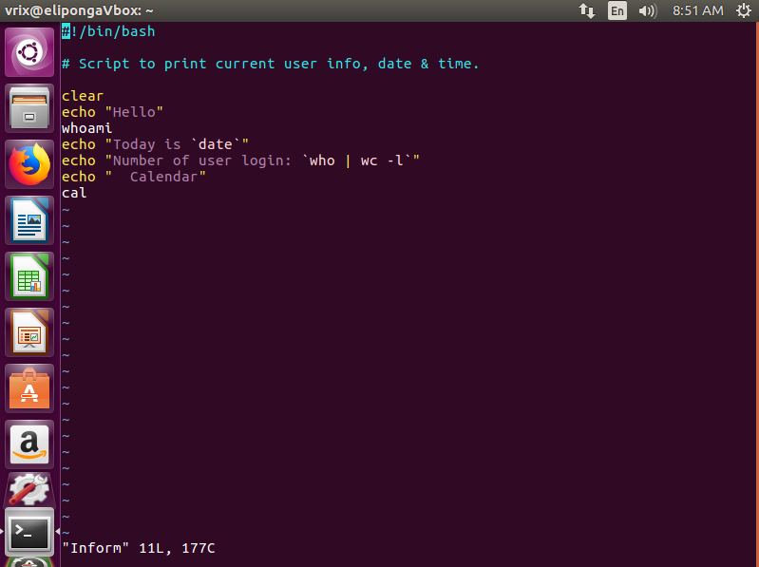

* **Saving file and setting executable pemission:** Press the **esc** button then type “:wq” to write the file and to quit the vim editor application. After that type “chmod 755 Inform” to set the user’s current permission to be able to **READ**, **WRITE** and **EXECUTE** the Inform file, type “ls -l Inform” to show the Inform file’s permissions.

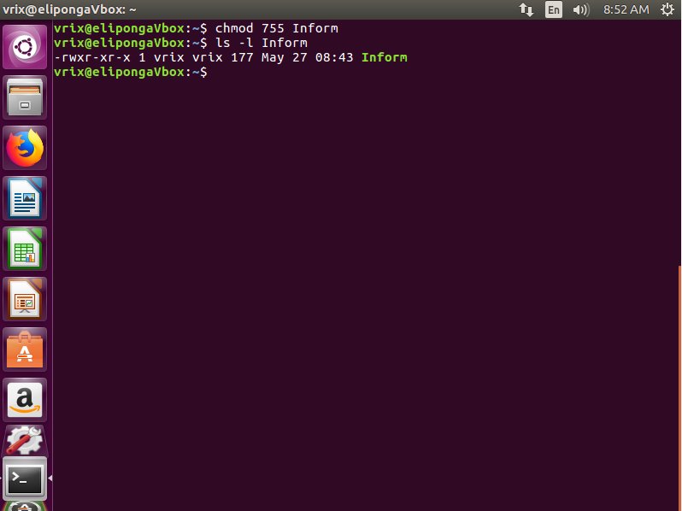

* **Executing the file**: Type in “**bash Inform**”, “**sh Inform**”, or “**./Inform**” in the terminal application to execute and run the Inform file.

